**GIT Considerations**

1. Use git to maintain below coding components only not configuration(we can aslo maintain configuration items in git but it’s very hard to merge when with Change Request’s changes)
   1. Apex Classes
   2. Aura Components
   3. Triggers
   4. Visualforce pages
   5. Visualforce Components
   6. Custom Labels
2. Use separate sandboxes for Phase 2 development and Change Requests
   1. TMDEV sandbox for Phase2
   2. DEV sandbox for CRs
3. Branches :
   1. Master Branch – is for base branch, it has
   2. Phase 2 Branch – is for Phase 2 development and it is for TMDEV sandbox.
   3. CR Branch – is for Change Requests development and it is for DEV sandbox.
4. Merging:
   1. Once done with development and testing any CR in DEV sandbox, merge the changes to Phase 2 Branch on timely basis (weekly).
   2. Configuration components needs to deploy manually through changeset to DEV to TMDEV inorder to sync the sandboxes to avoid conflicts.

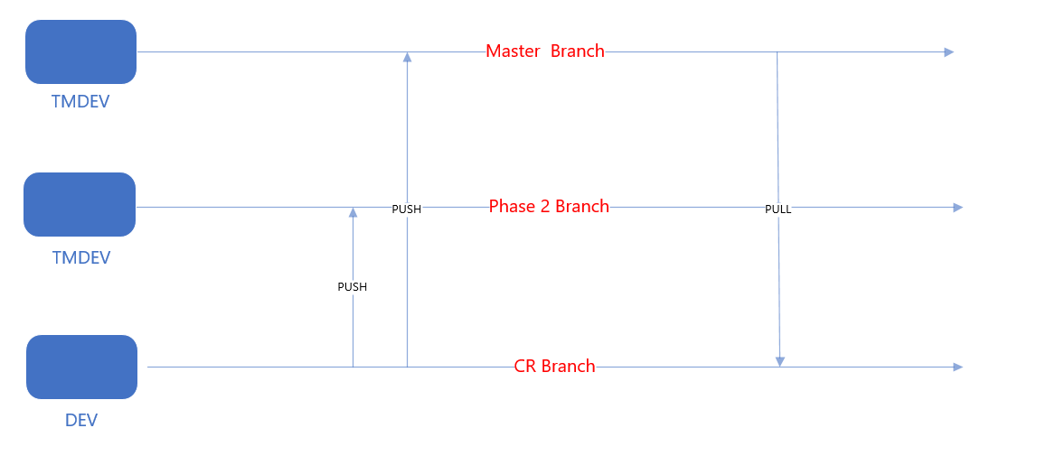

Git Configuration

1. Create repository in git and get the URL
2. Setup git in IDE (using git plugin in Ecplise, using git package control Sublime)
3. Navigate to package manager and type “install package” (cntl+alt+p)

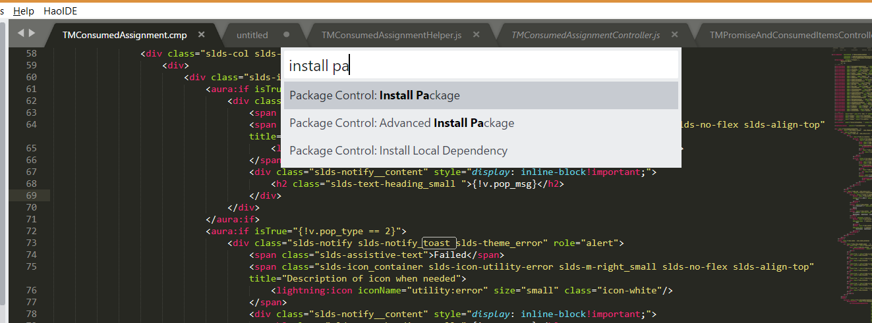

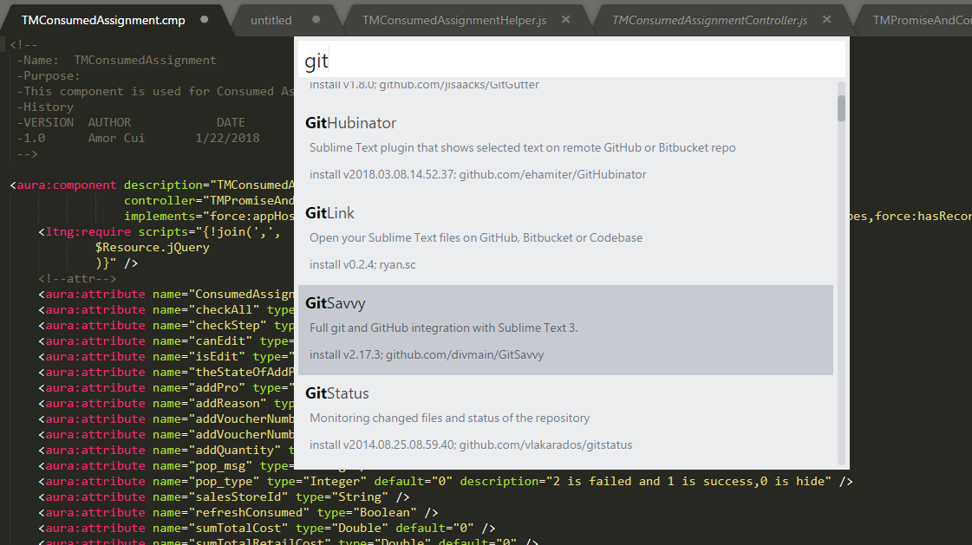

1. Install the git client (Sourcetree, Tortoise, git batch) to perform push/pull/merge operations to git repository.
2. Below you can see the git client “**SourceTree**” with recently changed components.

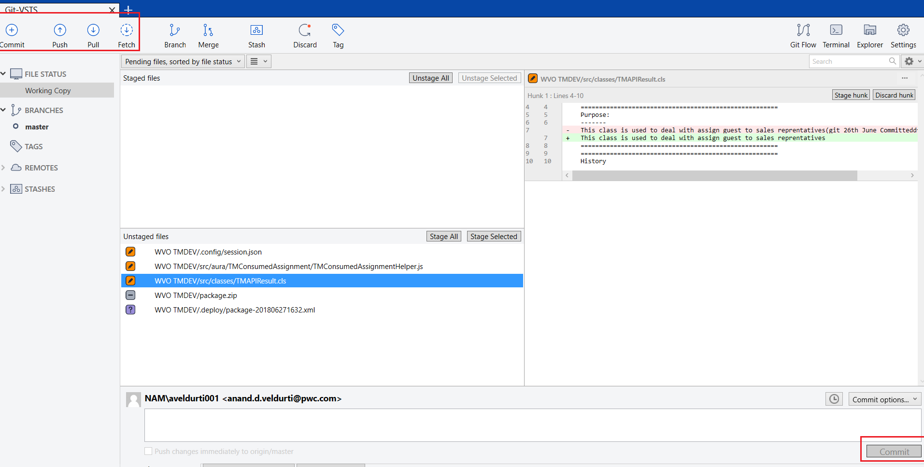

1. If multiple users perform push on same class then git client will give a error message like below.

